**Project Report**

**Project On:** “Student Report Card System in C++”

**Submitted By:** 1. Mayuri Kolhe. (21471)

2. Dnyaneshwari Hole. (21472)

3. Kartiki Khare. (21494)

**Project Summary:**

**1. Project Objective:**

Preparing report cards for number of students involves same task need to be performed every time. As this work involves doing calculation on same rules to make final results for each results and writing it manually on report card using pen and paper. So to eliminate such type of work, it’s better to achieve this work using computer system. Teachers or persons who will responsible for preparing report card have to enter only marks of each subject for every students and processing work will take care by the computer system in order to prepare final report card. Even system will relieve teachers for writing manually on report card and providing print facility by which, it will enable them to display the marks of each students on paper by just one click. As system has been provided with all maximum possibility to make their task easier, so number of features has been made available to continue the task without any intervention. It will only not prepare the report card, but also able to store data of each students, so that it can be accessed any time and if required can make modification as per requirement. The concept of graphics has been used which will make its user to use this system in an easy manner.

**2. Existing System:**

As the report card is to be prepared to time, so that results can be declared on desired date, it was not possible manually to achieve this goal. All the tasks has to be performed by the class teacher and these teachers also involved in other activities such as checking papers, taking exams, giving lectures etc. So it was not possible for them to tackle all these tasks at a time. Even some modification is required, they have to start from the beginning like, searching files to get particular student records, going through each subject paper and make alteration if found correct.

**3. Proposed System:**

This system has been developed to eliminate the repetitive tasks which is to be performed manually thus saving time and investment. This new system will store all the student records along with their marks and report card details, by which teachers and admin will able to retrieve these records whenever they required. It will enable teachers to get information on various sections such as list of failures students, list of toppers students, students list who have failed in particular subject etc using the predefined rules set by the institutions. Apart from these searching and sorting mechanism has been used to make these tasks faster. It will enable teachers to make report card, by entering subject marks, viewing report card of all or particular student, easy navigation system from moving one module to next module while using this system.

**4. Tools Used:**

1. Windows 10
2. Turbo C++ 3.2

**5. Features of Project:**

File handling has been used for the effective implementation of all the typical features of this project. The key features of Student Report Card System are:

1. **Create student report card record**:

This feature creates a new student record containing his marks. For this the information to be provided are the name and roll no. of the student, and the marks obtained by him/her in 5 subjects – Physics, Chemistry, Math, English and Computer Science.

2. **Read all students report card record**:

The void display_all() function in this student report card system project in C++ has been used for this feature. It basically shows the progress report of all the students added in file. This feature displays the roll no. and name of all the students, the marks obtained by them in 5 subjects – Physics, Chemistry, Math, English and Computer Science, along with the percentage and grade of each student.

3. **Read specific student’s report card record**:

This feature is same as the one explained above, except it shows the progress report and relevant [data](https://www.codewithc.com/data-visualization-java-project/) related to a particular student.

4. **Display all students’ grade report**:

This feature enlists all the students’ record saved in file. The grade report is displayed in a tabular form with roll no. and name of the students, marks achieved in the five subjects, and the grade and percentage obtained by them.

5. **Modify student’s report card record**:

In student report card system project in C++, this feature is used to edit the report card record of a particular student. For this, the name and roll no. of the student is sought. Upon successful modification, the program displays the message “Record Updated”. If no record of student is found in file, it displays the message “Record not found”.

6. **Delete student record**:

This feature deletes the report card record of a particular student; it first of all asks for the name and roll no. of the student whose record is to be deleted.

**6. Header Files Used:**

* #include<conio.h>
* #include<stdio.h>
* #include<process.h>
* #include<fstream.h>
* #include<iomanip.h>
* #include<iostream.h>

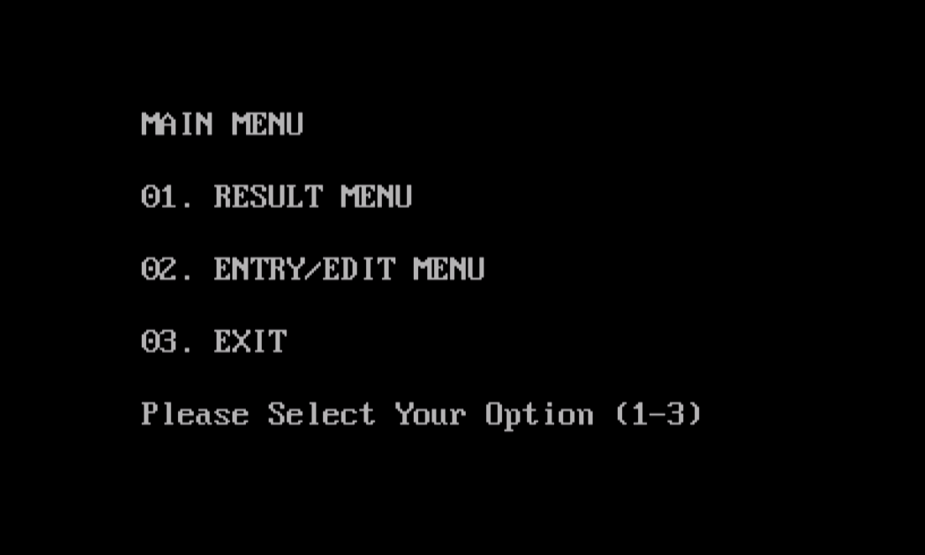**7. Project Outputs:**

